**Day 3 – E-Mail Service**

1. Research the following internet protocols related to e-mail services.
   1. SMTP Protocol
   2. POP3 Protocol
   3. IMAP Protocol
   4. Web Mail
2. Use the following resource as a starting point:  
   <https://askleo.com/what_is_pop_or_pop3_or_a_pop_account_and_what_about_smtp/>
3. 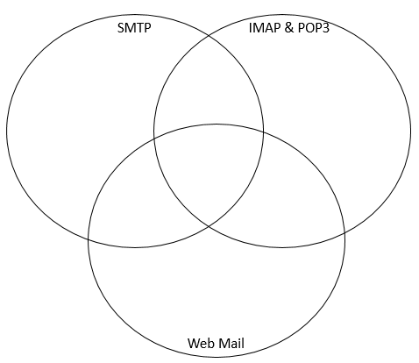Complete the following Venn Diagram to summarize your research.

Web-based email, such as Outlook.com, Yahoo, and the like, displays the email directly from their servers to your web browser. There’s no configuration needed other than logging in. They may use SMTP (and perhaps even IMAP or POP3) behind the scenes to get and send email, but that’s nothing you’d ever need to see, know, or worry about. Web-based email, such

Allows to send mail

Used by e-mail clients

Two protocols which take care of the email flow (send and receive respectively) on the internet.

Allows your PC to send mail

Web-based email, such as Outlook.com, Yahoo, and the like, displays the email directly from their servers to your web browser. There’s no configuration needed other than logging in. They may use SMTP (and perhaps even IMAP or POP3) behind the scenes to get and send email, but that’s nothing you’d ever need to see, know, or worry about.

POP3- In computing, the Post Office Protocol is an application-layer Internet standard protocol used by e-mail clients to retrieve e-mail from a mail server. POP version 3 is the version in common use.

IMAP- In computing, the Internet Message Access Protocol is an Internet standard protocol used by email clients to retrieve email messages from a mail server over a TCP/IP connection.

The Simple Mail Transfer Protocol is a communication protocol for electronic mail transmission. As an Internet standard, SMTP was first defined in 1982 by RFC 821, and updated in 2008 by RFC 5321 to Extended SMTP additions, which is the protocol variety in widespread use today.